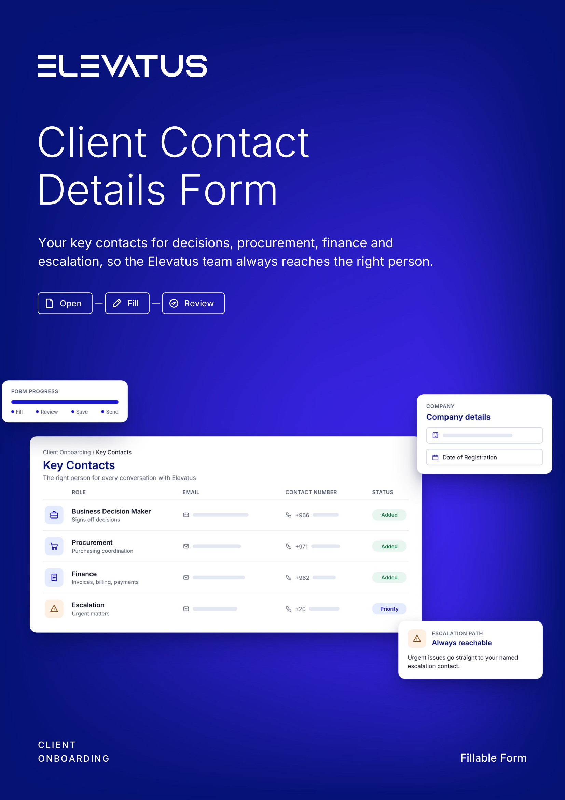

CLIENT ONBOARDING
Client Contact Details
Please provide your company's key contacts so the Elevatus team can coordinate effectively with the right people. All fields are required. Include the country code in all contact numbers.
 1 Open  In Word or Google Docs |  2 Fill  Sections 01 to 05 |  3 Review  Check your answers
01 Company details
Who is registering with Elevatus.
Date of Registration * |  | Company Name *
DD/MM/YYYY |  | Registered company or trading name

02 Business decision maker
The person who signs off decisions for your company.
Business Decision Maker Name *
First and last name

Business Decision Maker Email * |  | Business Decision Maker Contact Number *
 |  | +
Work email, for example name@company.com |  | Country code (e.g. +966), then the number

03 Procurement contact
The representative for purchasing and procurement coordination.
Procurement Contact Name *
First and last name

Procurement Contact Email * |  | Procurement Contact Number *
 |  | +
Work email, for example name@company.com |  | Country code (e.g. +966), then the number

04 Finance contact
The representative for invoices, billing and payment coordination.
Finance Contact Name *
First and last name

Finance Contact Email * |  | Finance Contact Number *
 |  | +
Work email, for example name@company.com |  | Country code (e.g. +966), then the number

05 Escalation contact
The point of contact for urgent matters or issues requiring escalation.
Escalation Contact Name *
First and last name

Escalation Contact Email * |  | Escalation Contact Number *
 |  | +
Work email, for example name@company.com |  | Country code (e.g. +966), then the number

